**PATENT**

**SIMPLE CALL FLOW**

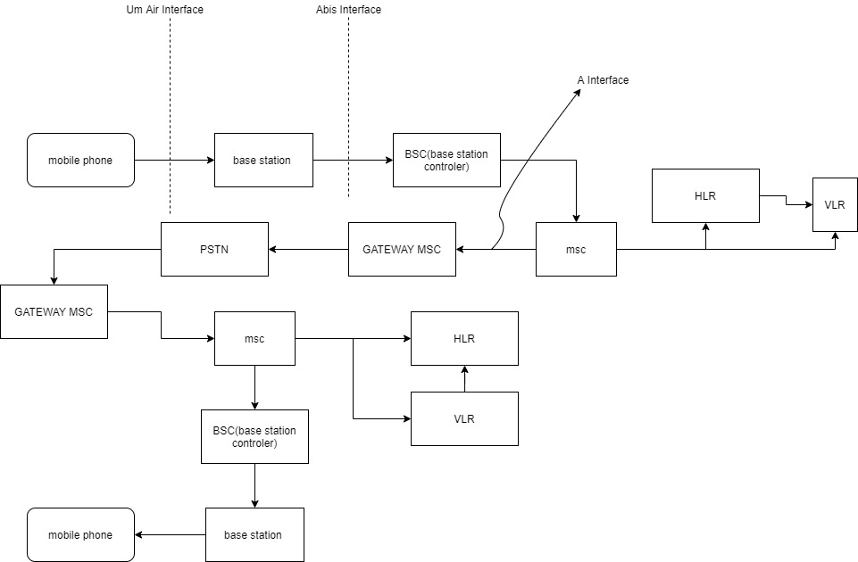

1. **Present time call flow**
   1. **Mobile phone to base station** 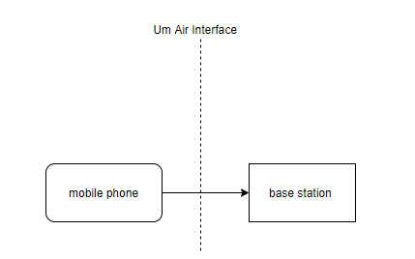

Between the mobile station and base station the UM air interface takes place.

Firstly a MS will setup a connection between the MS and BS by the help of radio protocol, LAPDm protocol and RR protocol. By the help of these protocol a channel has been established by which a MS directly communicate with the MSC(Mobile Switching Centre).After making a successful communication to the MSC the MM protocol comes into play.

Our project is totally based on this MM protocol.

* 1. **MS to MSC**

MS TO MSC.jpg

The MM protocol basically works between the mobile station and the MSC as shown in the fig. below

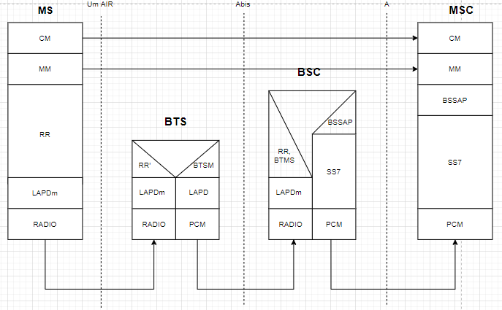

Here we can see that the MM protocol is between MS to MSC. The content which is transferred through the MM protocol is different in ‘EMERGENCY CALL’ and ‘SIMPLE CALL ‘.First message through this MM protocol from MS to MSC is CM request .

.MS TO MSC CM.jpg

When we make an emergency call a “CM REQUEST” is sent to the network from our mobile station by means of which our network identify what type of call it is.

Content of CM request message

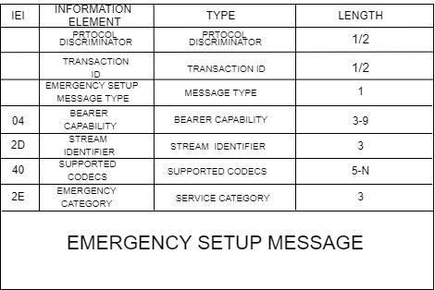

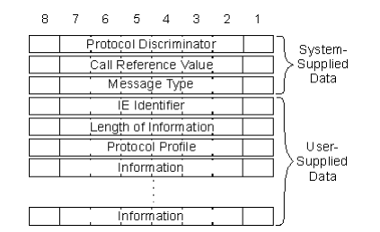

* + 1. **PROTOCOL DESCRIMINATOR**

Prototcol discriminator discriminates between the two protocols by which the network side comes to knows that from which protocol this message was generated for example.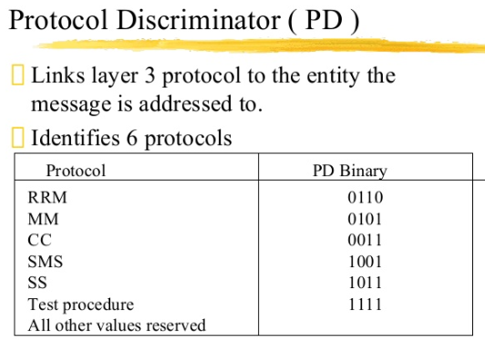

**Frame structure for protocol discriminator.**

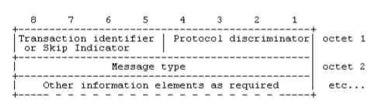

* + 1. **TRANSACTION IDENTIFIER**



In the above frame structure 5-8 bit consist of transaction identifier or skip indicator for every type of MOBILITY MANAGEMENT MESSAGE. When any mobile station wants to send the CM REQUEST, LOCATION UPDAATE REQUEST type of request or at the time of receiving these type of request messge from the network the skip indicator are used these type of bits format..

* Any skip indicator received with any other no rather than 0000bits is being ignored by the network and mobile station because the message with skip indicator other than 0000 is considered as error.
* 5-7 bit is for TI and 8bit of first octet is for TI flag.
* If the message of transaction is initiated from the user side then the flag is ‘0’ and ‘1’for others.
* Hence the TI flag identifies who allocated the TI value for this transaction and the only purpose of the TI flag is to resolve simultaneous attempts to allocate the same TI value.

**1.1.3: Frame for transaction identifier**

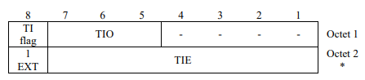

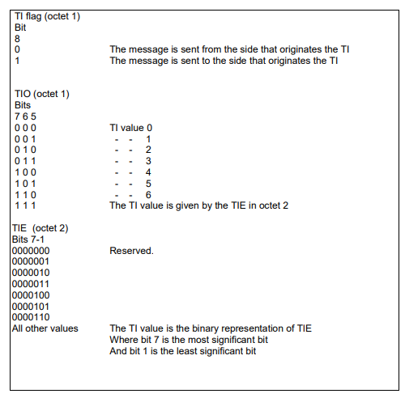

* + 1. **MESSAGE TYPE**

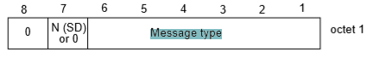

* Here bit 8 bit for the connection to core network earlier than the R99 is assigned as ‘0’ and bit 7 is reserved for the sequence number in messages sent from the mobile station. The messages that are sent by the network side is coded as ‘0’ for both 7 and 8 bits.
* The connection to the core network of R’99 and later, bits 7 and 8 are reserved for sending the sequenced number in messages from the mobile station and the messages sent from the network side the 7 or 8 bit is coded as ‘0’.

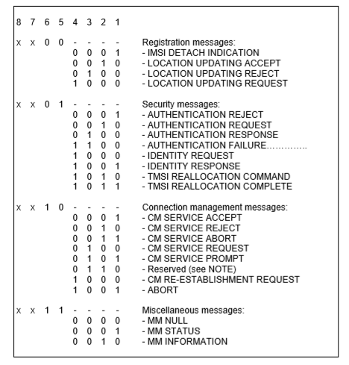

We use the reserved 0110 bit in our project for the modified emergency type call.

.

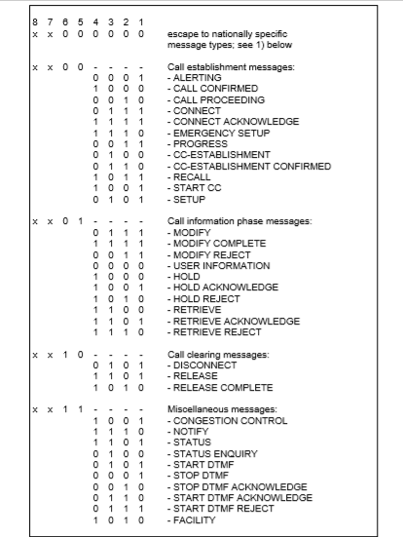

* + - 1. **Messsage type without change**

The octet of the message type is



So here at present the 8 and 7 bit is permanently zero for the R’99 and later type networks and for R99 the 8 bit is set as zero and the 7 bit is reserved for the sequence number of the message. Bit 6 and 5 are set by using the table given below. For example when the message is from connection management message then it will be 10.

Also the bit from 4 to 1 depends on the table given below



So if this message is CM service request message, then the bit 4 to 1 will set to 0100. Through this the MSC comes to know that this is a CM service request message. Through the table given below the MSC comes to know that which type of call it is whether it is a simple call or an emergency call.

* + 1. **BEARER CAPABILITY**

The purpose of the bearer capability information element is to describe a bearer service. The use of the bearer capability information element in relation to compatibility checking is described in annex B.

The bearer capability has minimum length of 3 octet and maximum length of 16 octet. Bearer capability frame structure is

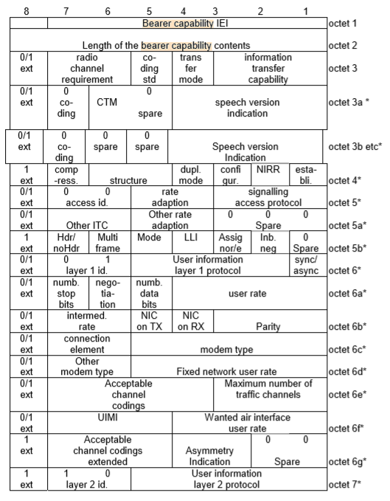

Mobile stations that are not supporting the A/Gb mode and GERAN Iu mode coded ‘0’ for the following:

* Maximum number of traffic channels (octet 6e, bits 1-3)
* Acceptable Channel coding(s) (octet 6e, bits 4, 5 and 7)
  + 1. **STREAM IDENTIFIER**

The purpose of the stream identifier (SI) information element is to associate a particular call with a Radio Access Bearer (RAB), and to identify whether a new traffic channel shall be assigned within the interface controlled by these signalling procedures. The SI value indicated in the CC protocol shall be sent in the RAB setup message. And mobile station is informed the relationship between the call and the RAB.

Frame structure for stream identifier is :

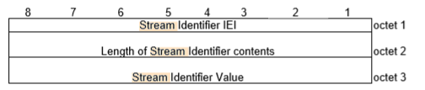

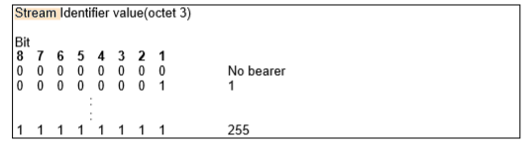

* + 1. **SUPPORTED CODEC LIST**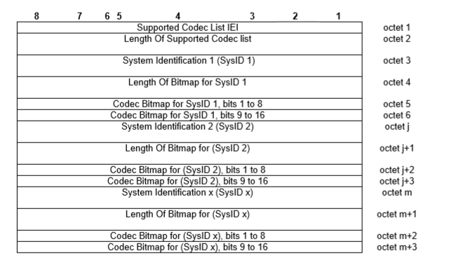 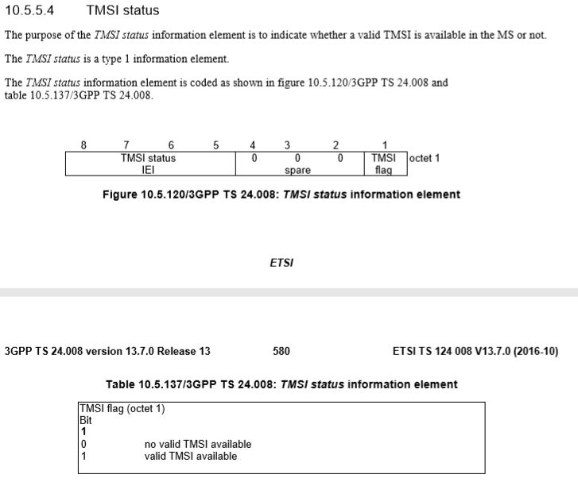

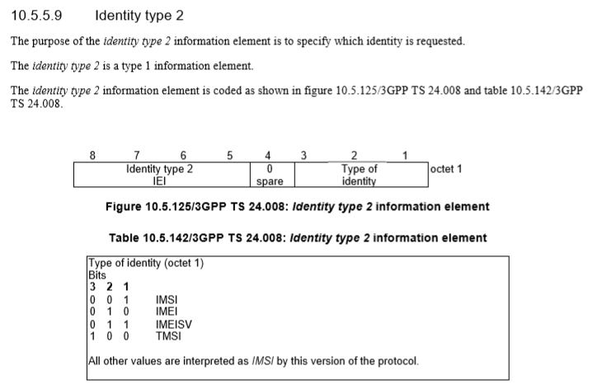

* + 1. **SERVICE CATEGORY**

The purpose of the Service category information element is to provide the network with information about services invoked by the user equipment.

Service category is a type 4 service and having minimum 3 octets.

Frame format for the service category is 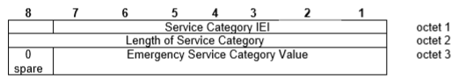

Bit code stack for this is:

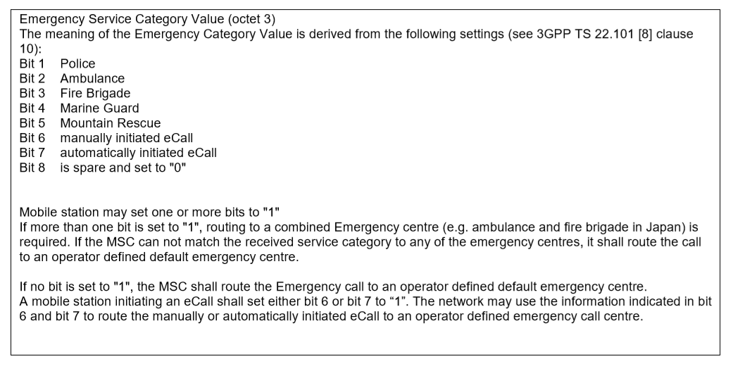

AFTER THE REQUEST IS BEING SERVERD TO MSC

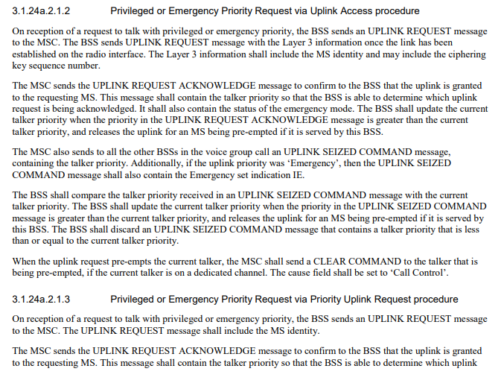 details of connection between the msc and bss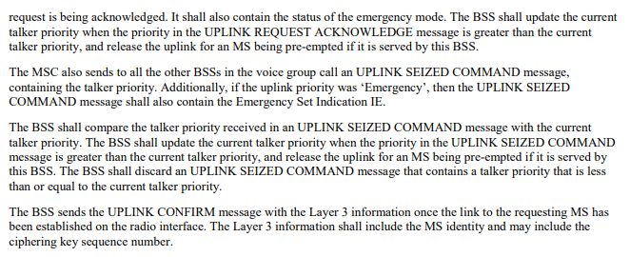

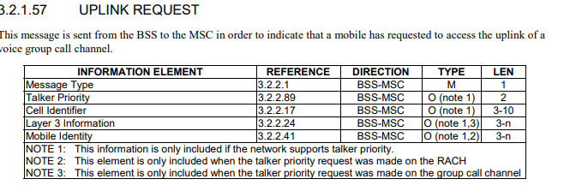………….[1]

This is the information that is shared by the MS through MM protocol and after this the MSC sends back a message to the MS that could be anything whether CM service request accepts or rejected by the MSC. If the request is rejected the reason for the rejection will also be mentioned.

So through this content we use the message type content for telling the MSC that this is a special type of emergency calling.

**1.1.9 Solved frame structure for message type**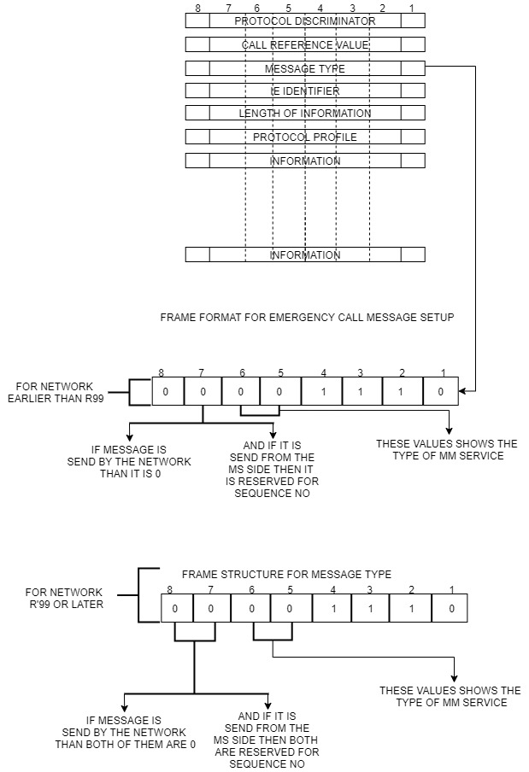

1. Changes in our project in MM protocol between MS to MSC.

In this our main task is to tell the MSC that it is a special type of emergency calling. For this we use the reserved bit(0110) in the connection management message as shown in below table.



Through which the MSC knows that this is not an emergency number.

When MSC comes to know its not an emergency number after this it will sends the confirmation request to the MS and forward this to the AAA server as followed in the roaming process.

* 1. 3GPP AAA

As there are two things AAA server and AAA proxy. The HPLMN side AAA is named as the AAA server and the VPLMN side AAA is named as proxy as shown in figure.

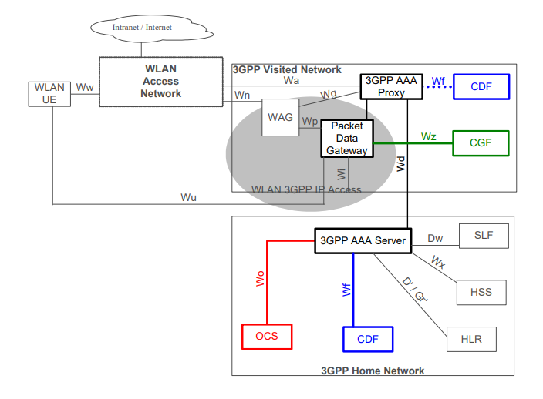

As in this the HPLMN and the VPLMN ic connected through the wd interface. The detailed study of this roaming structure is defined in (ETSI TS 123 234 V12.0.0 page number 31).

Some of the basic functions performed by both proxy and server are

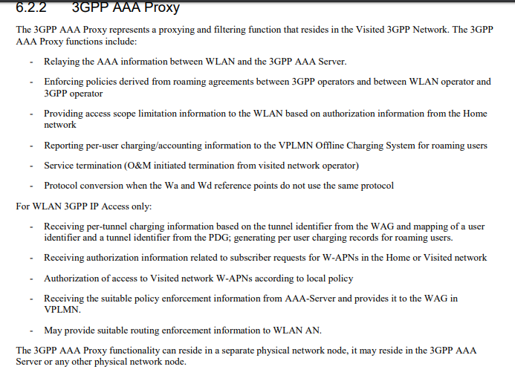

These are the functions of the AAA proxy side

The function of AAA server are

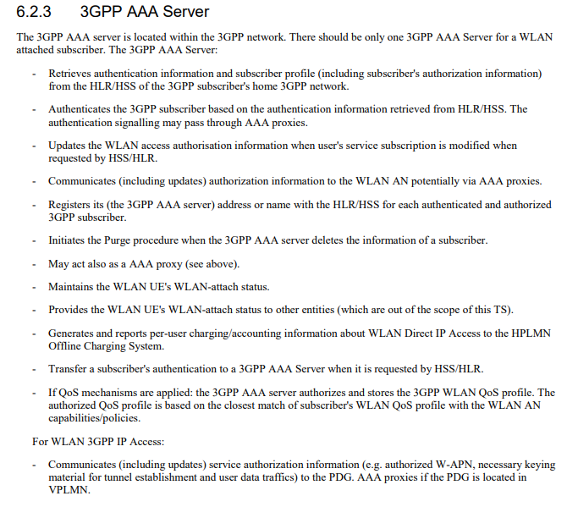

1.2.1 Detailed function of AAA

When the AAA proxy received the request for verifying the user then the AAA proxy sends the DER message to the HPLMN by the help of the PLMN ID which is the MCC+MNC of the user detailed about this is in the (ETSI TS 123 003 V14.3.0).

The format of the DER message is

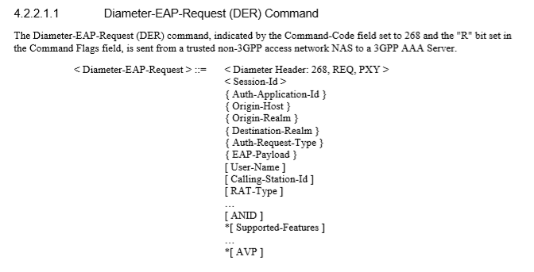

Detailed about this is defined in (ETSI TS 129 273 V10.3.0).

After receiving this DER message the AAA server searches the ANID into its own data base if the ANID is found in its own data base it will send DER message reply. The reply of DER consist of details that is needed for generating a CDR or as signed during the agreement. After this the server sends a DER answer message to the proxy. The content of the message is

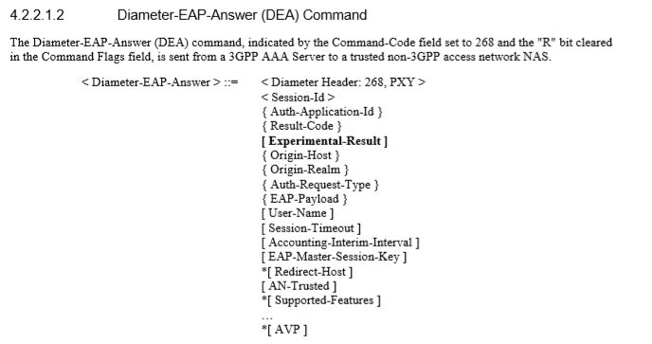

Detailed procedure of this is defined in clause 5.1.2 of(ETSI TS 129 273 V10.3.0).

1.2.2 Detailed content for DER message

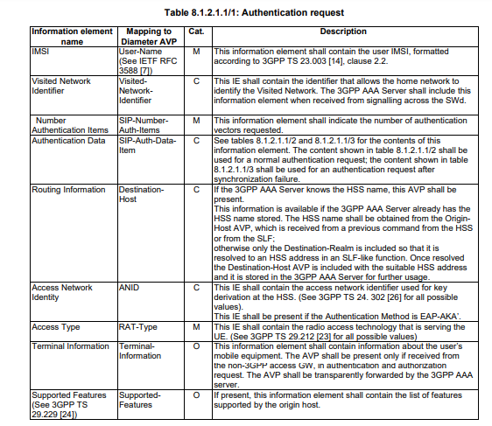

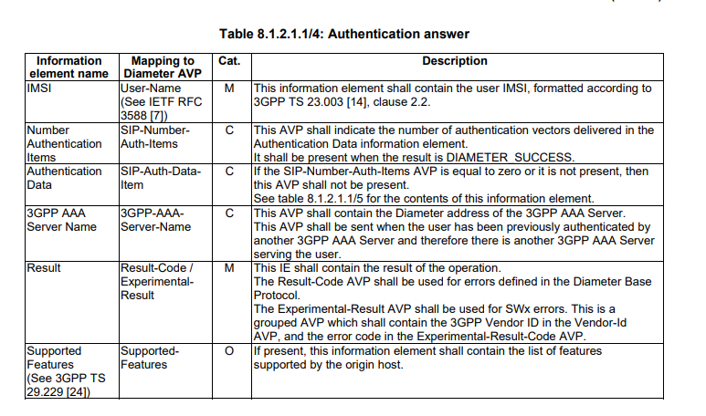

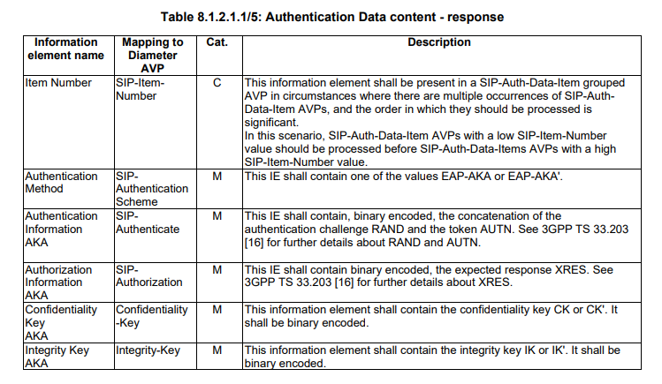

Detailed in (3GPP TS 29.273 V8.8.0).and also in the fig

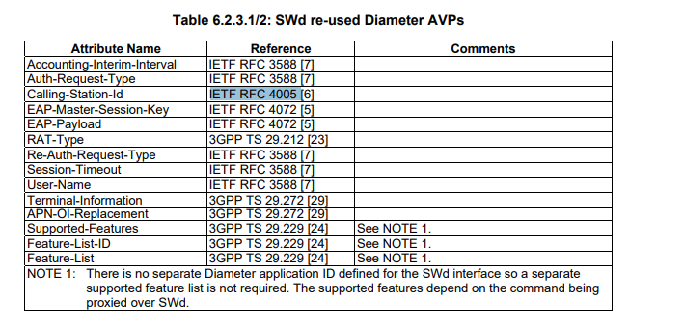

**REFERENCES**

1.<https://www.etsi.org/deliver/etsi_ts/148000_148099/148008/14.01.00_60/ts_148008v140100p.pdf>